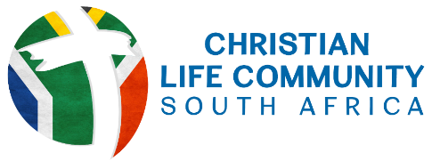
FORMATION QUESTIONNAIRE
Name
How long have you been a member of CLC?
CLC Region  Please tick the relevant block
  Eastern Cape | Gauteng | Western Cape
Name of CLC Group Leader
How often does your CLC group meet?
What is the format of your meeting?  Please tick the relevant block
  In-Person | Online
Which stage of the CLC journey best describes you?  Please tick the relevant block
  Exploring CLC but have not formally joined CLC | I am a CLC member before Temporary Commitment. | I am preparing for Temporary Commitment
  I have made Temporary Commitment | I am preparing for Permanent Commitment | I have made Permanent Commitment
I would like more information on …  Please tick the block(s) that apply to you.
  The Mission of CLC | Ignatian Spirituality | Community in CLC | Other (please specify below
If you selected OTHER for the previous question, please elaborate further.
Further Comments
Please share any further comments you have which you would like the National Formation Team to consider.

Thank you for the time you have taken to complete this questionnaire. Please email your response to Kaye Henrick at kayehenrick2@gmail.com

